| **Test Name** | | | Register account | | | |
| --- | --- | --- | --- | --- | --- | --- |
| **Use Case Tested:** | | | Register-Check Editable Fields | | | |
| **Test Description:** | | | Verify that registration form has input fields Username, email password and confirm password and that these are editable | | | |
| **Pre-conditions** | | | Register screen must be open | | | |
| **Post-conditions** | | | That all input fields are filled | | | |
| **Notes:** | |  | | | | |
| **Result (Pass/Fail/Warning/Incomplete)** | | **Pass** | | | | |
|  | **TEST STEP** | | | **EXPECTED TEST RESULTS** | P | F |
|  | Does Registration form have username input field | | | That input field exists | P |  |
|  | Does Registration form have email input field | | | That input field exists | P |  |
|  | Does Registration form have password input field | | | That input field exists | P |  |
|  | Does Registration form have confirm password input field | | | That input field exists | P |  |
|  | Type information into editable fields | | | That the user can type required details into input fields | p |  |
|  | Are passwords viewable | | | Passwords should show as asterisk’s | p |  |

|  |  |  |  |  |  |
| --- | --- | --- | --- | --- | --- |
| **Test Data Table** | | | | | |
|  | **1** | **2** | **3** | **4** | **5** |
| Username | tester2 |  |  |  |  |
| Email | tester2@gmail.com |  |  |  |  |
| Password 1 | tester2 |  |  |  |  |
| Password 2 | tester2 |  |  |  |  |

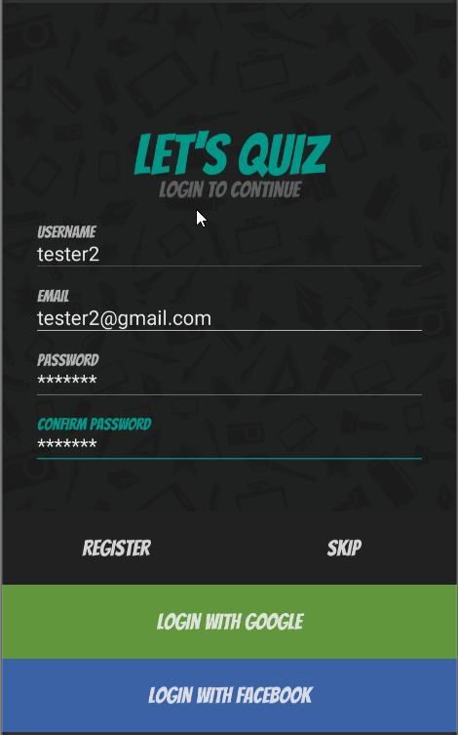

All fields editable and passwords show as asterick

| **Test Name** | | | Register account | | | |
| --- | --- | --- | --- | --- | --- | --- |
| **Use Case Tested:** | | | Register-Blank Username | | | |
| **Test Description:** | | | Verify that entering blank spaces on username field produces error message | | | |
| **Pre-conditions** | | | Register screen must be open  Internet connection must exist | | | |
| **Post-conditions** | | | Error message should be displayed | | | |
| **Notes:** | |  | | | | |
| **Result (Pass/Fail/Warning/Incomplete)** | | **Pass** | | | | |
|  | **TEST STEP** | | | **EXPECTED TEST RESULTS** | **P** | **F** |
| 1 | Leave username blank and hit register | | | Error message confirm username cannot be empty is displayed | **p** |  |

|  |  |  |  |  |  |
| --- | --- | --- | --- | --- | --- |
| **Test Data Table** | | | | | |
|  | **1** | **2** | **3** | **4** | **5** |
| Username blank | empty |  |  |  |  |
| Email | tester2@gmail.com |  |  |  |  |
| Password | tester2 |  |  |  |  |
| Confirm passwords | tester2 |  |  |  |  |

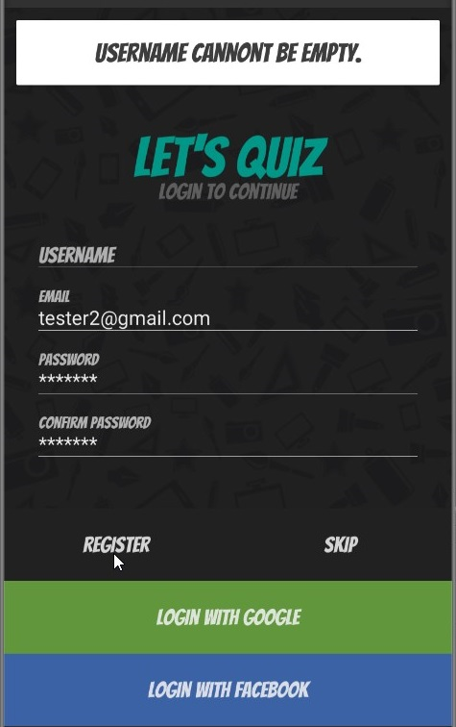

User name space empty error message displayed

| **Test Name** | | | Register account | | | |
| --- | --- | --- | --- | --- | --- | --- |
| **Use Case Tested:** | | | Register-Blank Email | | | |
| **Test Description:** | | | Verify that entering blank spaces on email field produces error message | | | |
| **Pre-conditions** | | | Register screen must be open | | | |
| **Post-conditions** | | | Error message should be displayed | | | |
| **Notes:** | |  | | | | |
| **Result (Pass/Fail/Warning/Incomplete)** | | **Pass** | | | | |
|  | **TEST STEP** | | | **EXPECTED TEST RESULTS** | P | F |
| 1 | Leave email blank and hit register | | | Error message confirm email cannot be empty is displayed | P |  |

|  |  |  |  |  |  |
| --- | --- | --- | --- | --- | --- |
| **Test Data Table** | | | | | |
|  | **1** | **2** | **3** | **4** | **5** |
| Username | tester2 |  |  |  |  |
| Email | empty |  |  |  |  |
| Password | tester2 |  |  |  |  |
| Confirm passwords | tester2 |  |  |  |  |

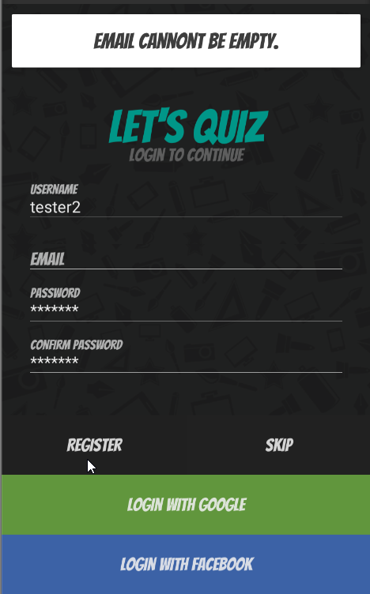

Email empty error message displayed

| **Test Name** | | | Register account | | | |
| --- | --- | --- | --- | --- | --- | --- |
| **Use Case Tested:** | | | Register-Blank password | | | |
| **Test Description:** | | | Verify that entering blank spaces on password field produces error message | | | |
| **Pre-conditions** | | | Register screen must be open | | | |
| **Post-conditions** | | | Error message should be displayed | | | |
| **Notes:** | |  | | | | |
| **Result (Pass/Fail/Warning/Incomplete)** | | **Pass** | | | | |
|  | **TEST STEP** | | | **EXPECTED TEST RESULTS** | **P** | **F** |
| 1 | Leave password blank and hit register | | | Error message confirm password cannot be empty is displayed | **P** |  |

|  |  |  |  |  |  |
| --- | --- | --- | --- | --- | --- |
| **Test Data Table** | | | | | |
|  | **1** | **2** | **3** | **4** | **5** |
| Username | Test123 |  |  |  |  |
| Email | test@test.com |  |  |  |  |
| Password 1 | Empty |  |  |  |  |
| Password 2 | Empty |  |  |  |  |

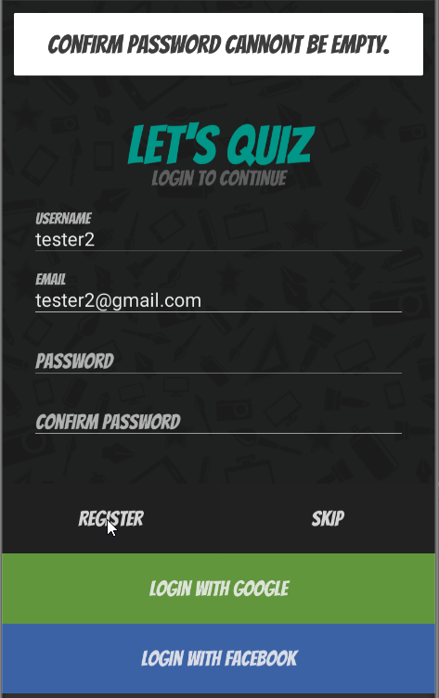

Password empty error message displayed

| **Test Name** | | | Register account | | | |
| --- | --- | --- | --- | --- | --- | --- |
| **Use Case Tested:** | | | Register-Blank confirm password | | | |
| **Test Description:** | | | Verify that entering blank spaces on password field produces error message | | | |
| **Pre-conditions** | | | Register screen must be open | | | |
| **Post-conditions** | | | Error message should be displayed | | | |
| **Notes:** | |  | | | | |
| **Result (Pass/Fail/Warning/Incomplete)** | | **Pass** | | | | |
|  | **TEST STEP** | | | **EXPECTED TEST RESULTS** | **P** | **F** |
| 1 | Leave confirm password blank and hit register | | | Error message passwords don’t match, try again should display | **P** |  |

|  |  |  |  |  |  |
| --- | --- | --- | --- | --- | --- |
| **Test Data Table** | | | | | |
|  | **1** | **2** | **3** | **4** | **5** |
| Username | tester2 |  |  |  |  |
| Email | tester2@gmail.com |  |  |  |  |
| Password 1 | tester2 |  |  |  |  |
| Password 2 | Empty |  |  |  |  |

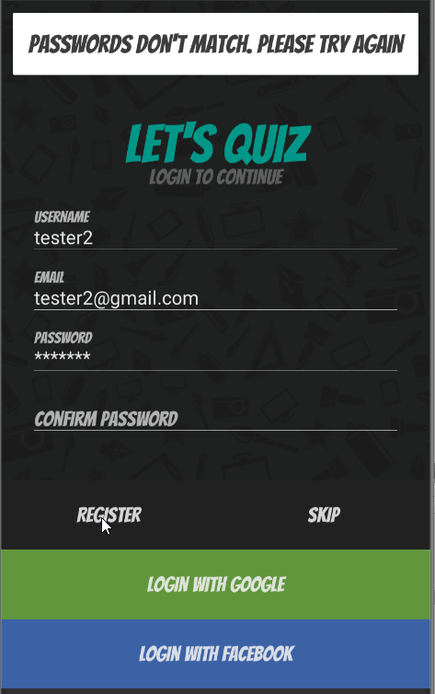

Second password empty error message displayed

| **Test Name** | | | Register account | | | |
| --- | --- | --- | --- | --- | --- | --- |
| **Use Case Tested:** | | | Register-Passwords Match | | | |
| **Test Description:** | | | Verify whether the password and confirm password send error message when they don’t match each other | | | |
| **Pre-conditions** | | | Register screen must be open | | | |
| **Post-conditions** | | | Error message should be displayed | | | |
| **Notes:** | | **Test failed it logged tester2 in** | | | | |
| **Result (Pass/Fail/Warning/Incomplete)** | | **Fail** | | | | |
|  | **TEST STEP** | | | **EXPECTED TEST RESULTS** | **P** | **F** |
| 1 | Enter to different passwords | | | Error message passwords don’t match, try again should display |  | **F** |

|  |  |  |  |  |  |
| --- | --- | --- | --- | --- | --- |
| **Test Data Table** | | | | | |
|  | **1** | **2** | **3** | **4** | **5** |
| Username | tester2 |  |  |  |  |
| Email | tester2@gmail.com |  |  |  |  |
| Password 1 | tester2 |  |  |  |  |
| Password 2 | tes124 |  |  |  |  |

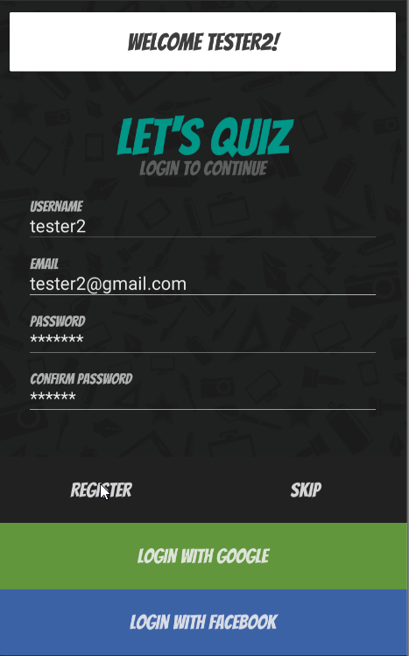

Signed in welcome tester2 displayed when no sign in should have occurred error message should say passwords don’t match, try again.

| **Test Name** | | | Register account | | | |
| --- | --- | --- | --- | --- | --- | --- |
| **Use Case Tested:** | | | Register- Submittal | | | |
| **Test Description:** | | | Verify that clicking on register button after entering all the mandatory fields, submits the data to the server | | | |
| **Pre-conditions** | | | Register screen must be open  Internet connection must exist | | | |
| **Post-conditions** | | | User must successfully register | | | |
| **Notes:** | |  | | | | |
| **Result (Pass/Fail/Warning/Incomplete)** | | **Pass** | | | | |
|  | **TEST STEP** | | | **EXPECTED TEST RESULTS** | **P** | **F** |
| 1 | Enter username | | | Username will be filled in | **P** |  |
| 2 | Enter email | | | Email will be filled in | **P** |  |
| 3 | Enter password | | | Password will be filled in | **P** |  |
| 4 | Enter password a second time to confirm | | | Password will be filled in | **P** |  |
| 5 | Hit register button | | | Details should be sent to server and account created and user account page should open | **P** |  |

|  |  |  |  |  |  |
| --- | --- | --- | --- | --- | --- |
| **Test Data Table** | | | | | |
|  | **1** | **2** | **3** | **4** | **5** |
| Username | tester2 |  |  |  |  |
| Email | tester2@gmail.com |  |  |  |  |
| Password 1 | tester2 |  |  |  |  |
| Password 2 | tester2 |  |  |  |  |

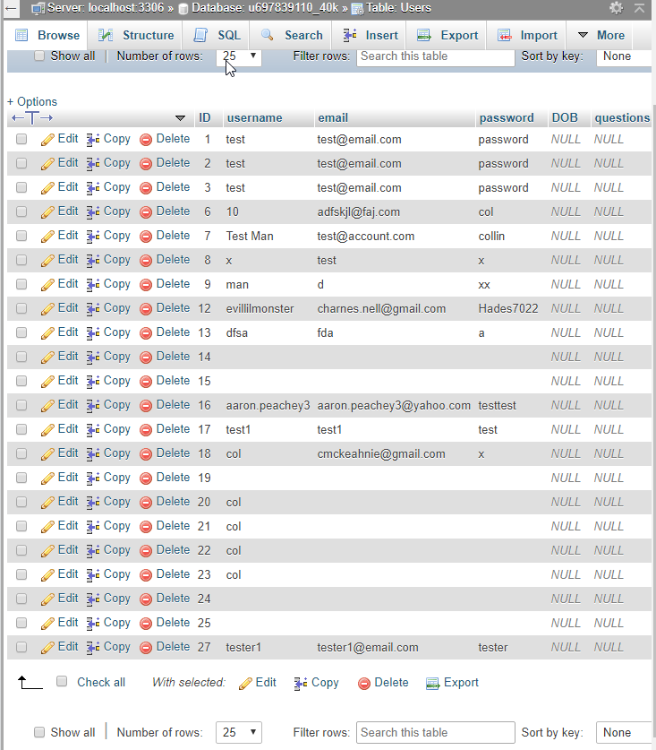

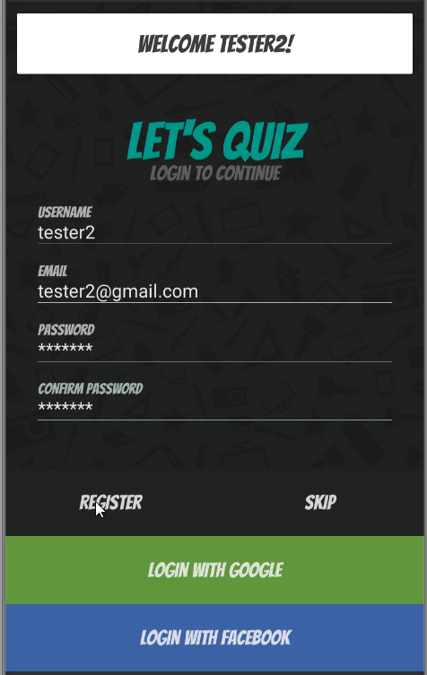

Database without tester2 account Details entered register pressed and welcome message displayed

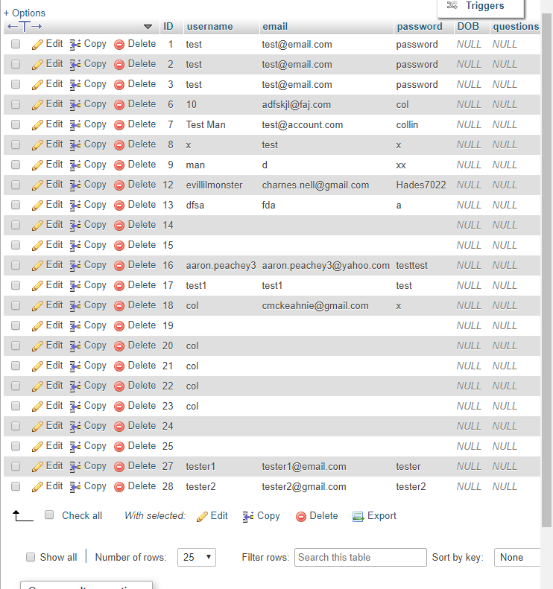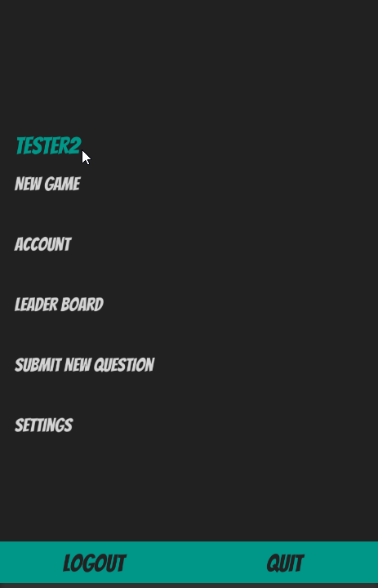

Scene changes to new game screen shows tester2 is logged in Database showing tester2 account details

| **Test Name** | | | Register account | | | |
| --- | --- | --- | --- | --- | --- | --- |
| **Use Case Tested:** | | | Register-Skip Registration | | | |
| **Test Description:** | | | Verify that pressing skip button works to advance forward or go back to register | | | |
| **Pre-conditions** | | | Register screen must be open | | | |
| **Post-conditions** | | | Warning should be displayed allowing user to either continue as guest or exit back to register page | | | |
| **Notes:** | | **Ran three times and worked all three .**  **Name should have changed to guest not part of this test but note worthy** | | | | |
| **Result (Pass/Fail/Warning/Incomplete)** | | **Fail** | | | | |
|  | **TEST STEP** | | | **EXPECTED TEST RESULTS** | **P** | **F** |
| 1 | Press skip button | | | Should display warning that informs user registering as a guest limits what you can do with a confirmation button or cancel button | **P** |  |
| 2 | Press confirmation button(register) on warning panel | | | Should advance to game choose panel | **P** |  |
| 3 | User name should change when on new game screen | | | Should say Guest |  | **F** |
| f | Press return button(cancel) on warning panel | | | Should return to register panel | **P** |  |

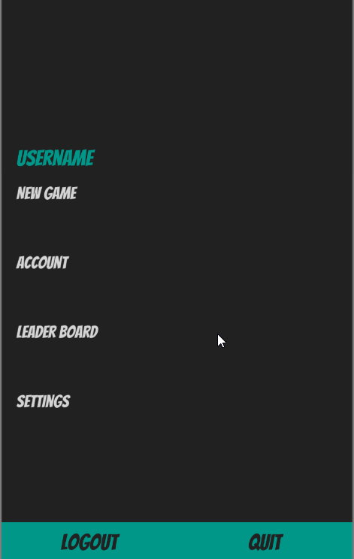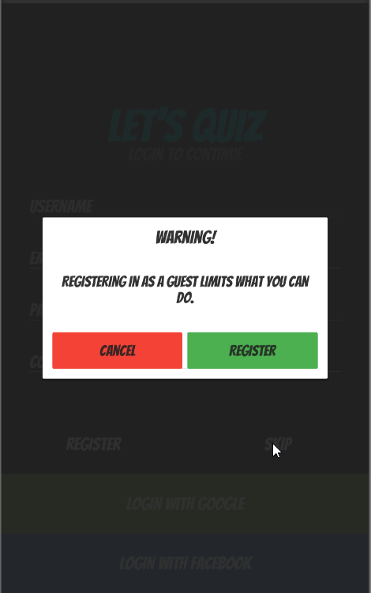

Hit skip warning displayed Hit register logged in as guest but no name change

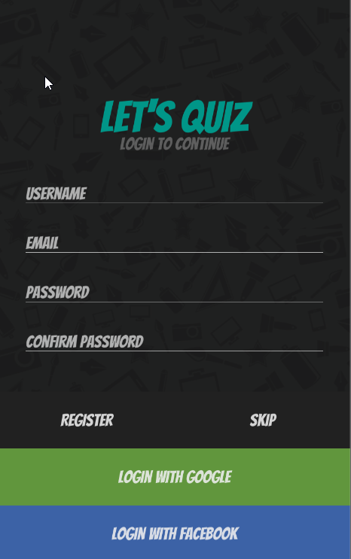

Hit cancel returned to register screen